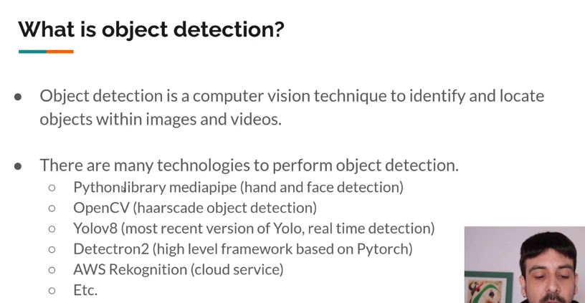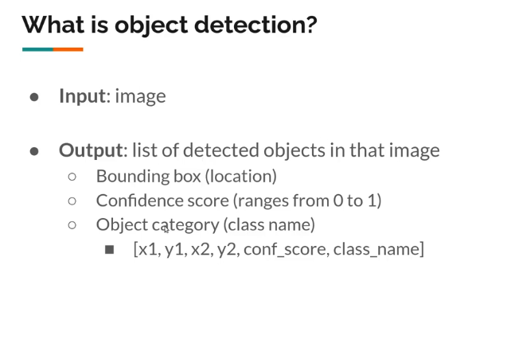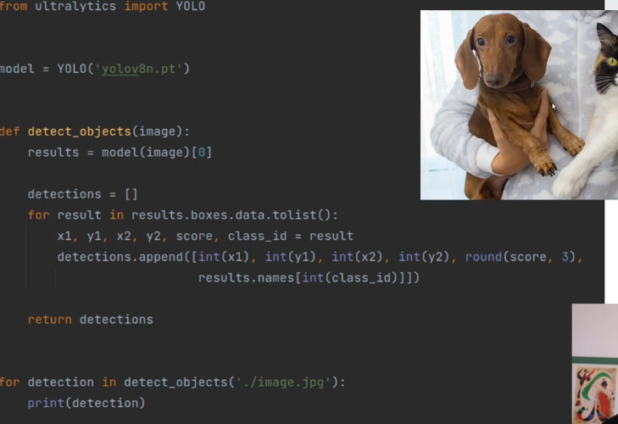

x1, y1 - coordinates of the top left corner and x2, y2 - coordinates of the bottom left corner for the bounding box.

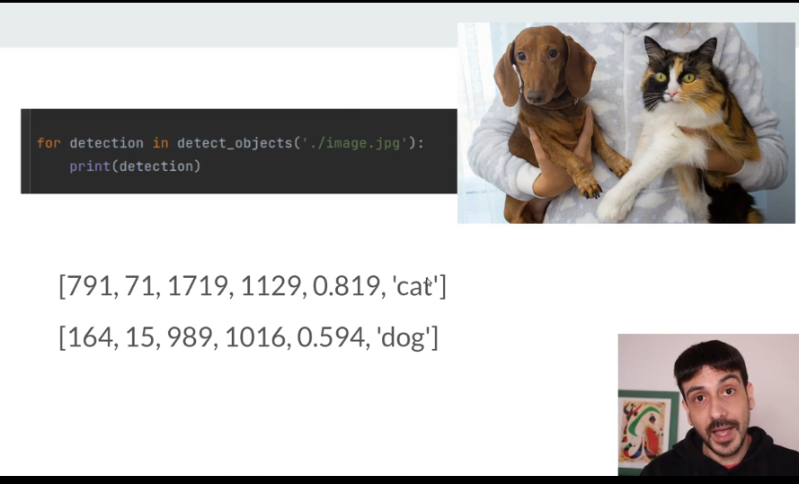

791, 71, 1719, 1129, is the bounding box of where the cat is located and 0.819 is the confidence score.

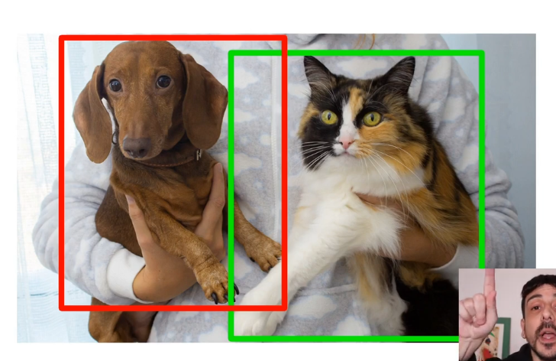

**OBJECT DETECTION METRICS**

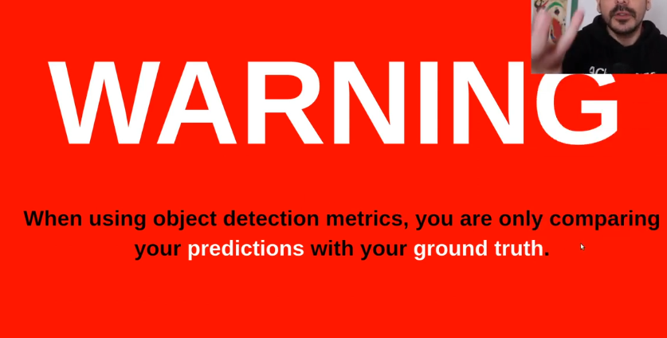

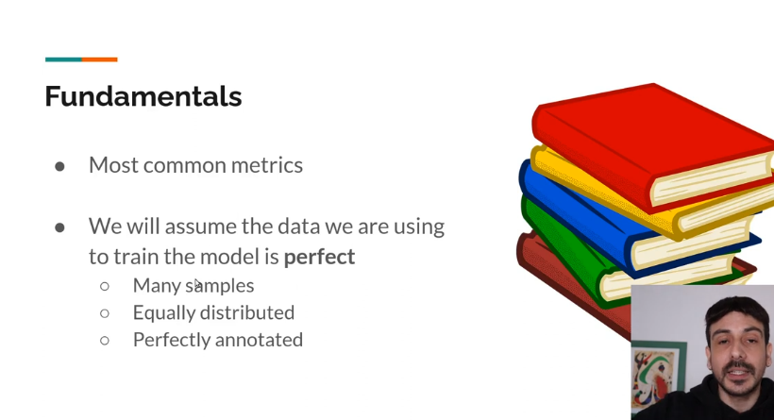

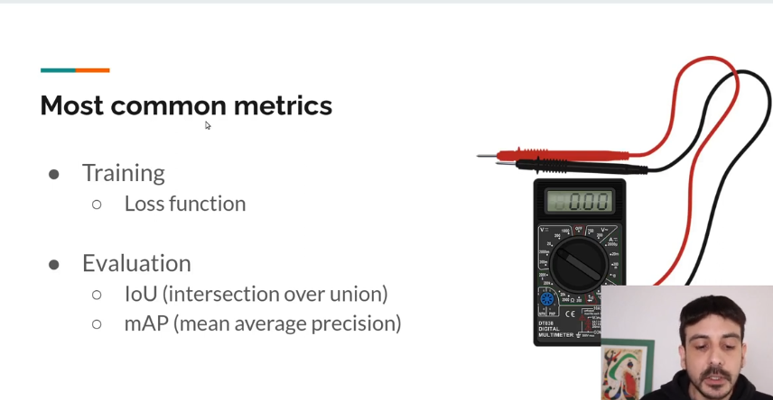

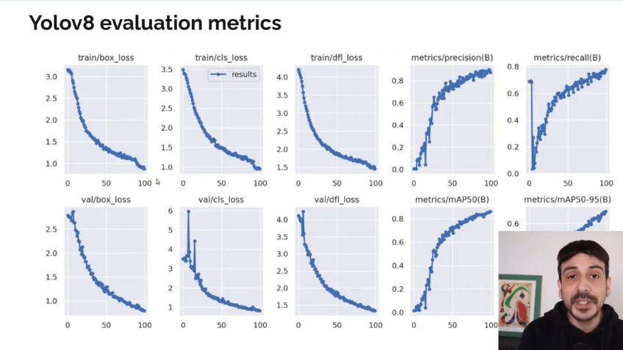

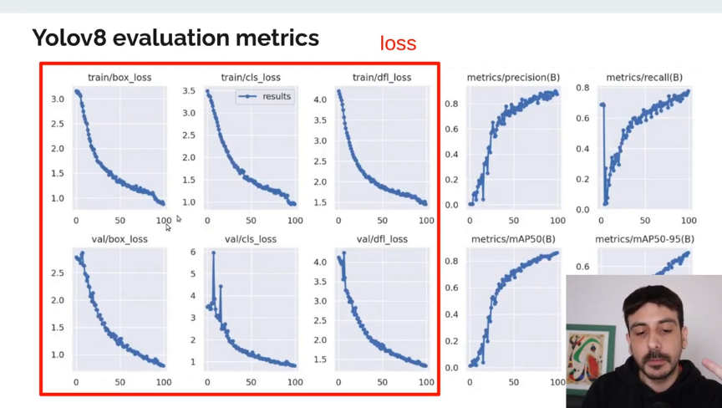

**Training loss**  - is a very important metric that’s why we have so many plots for loss

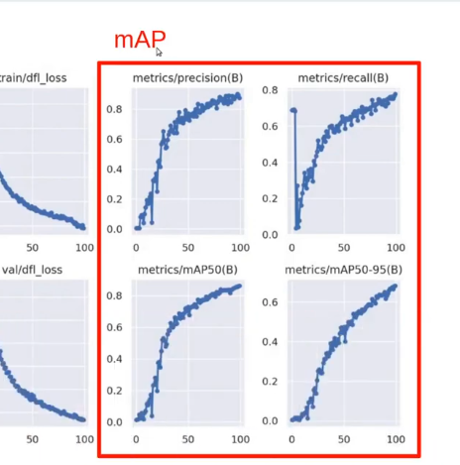

**NOTE:** Yolov8 the IoU is not provided

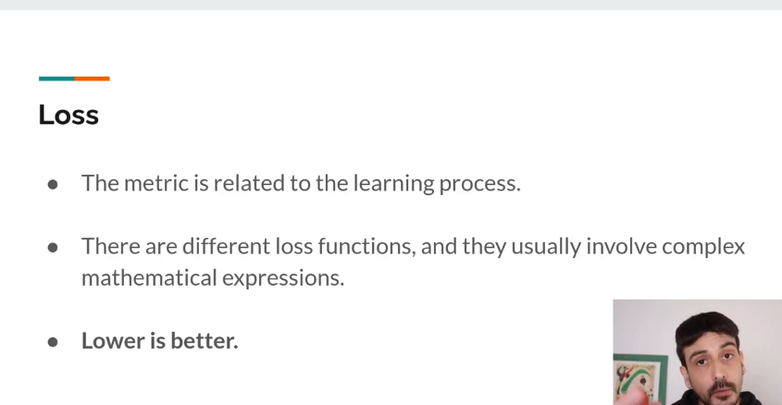

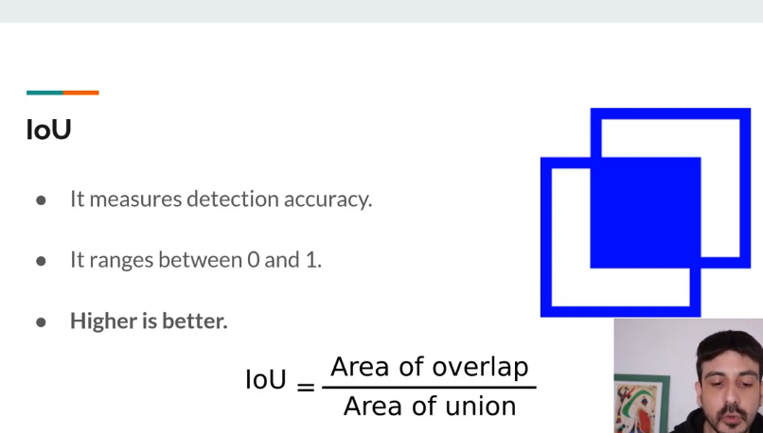

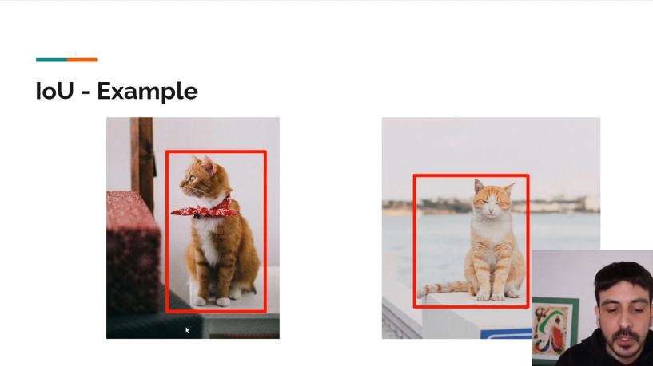

This is the ground truth with a perfect bounding box.

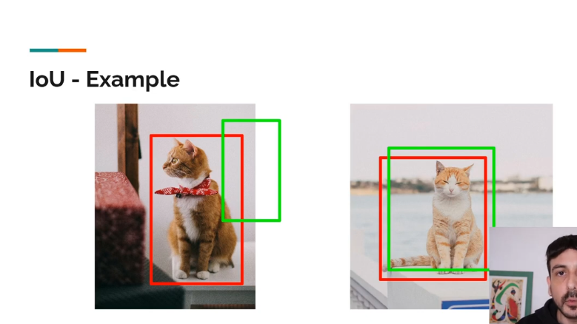

This is the detections with the object detector.

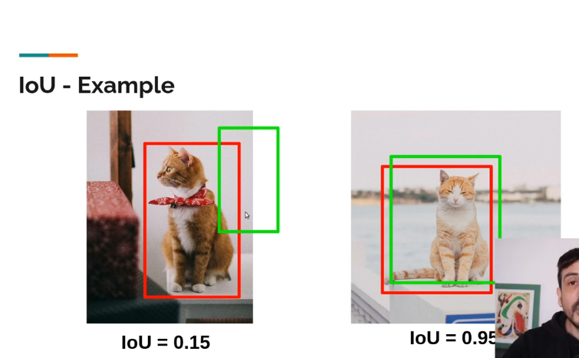

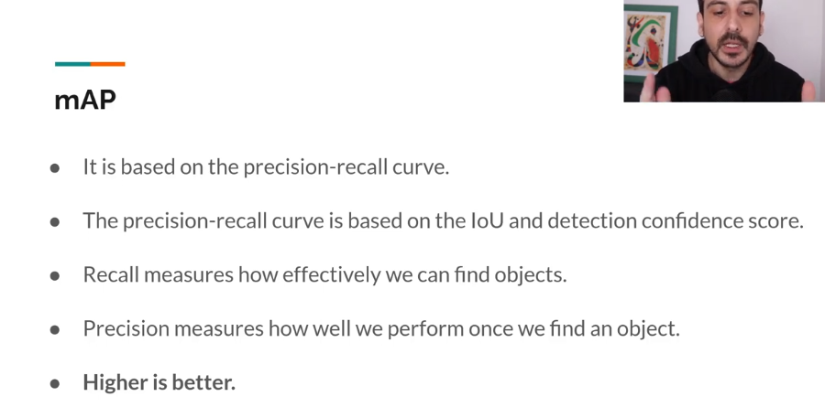

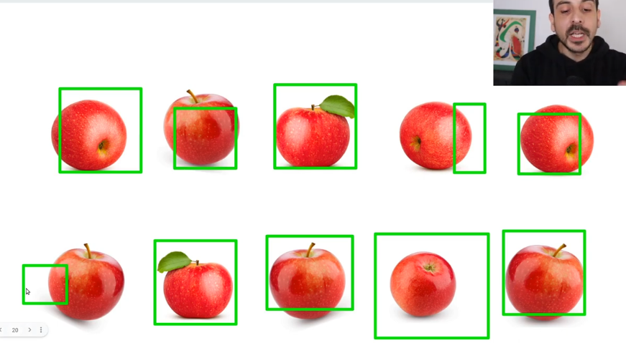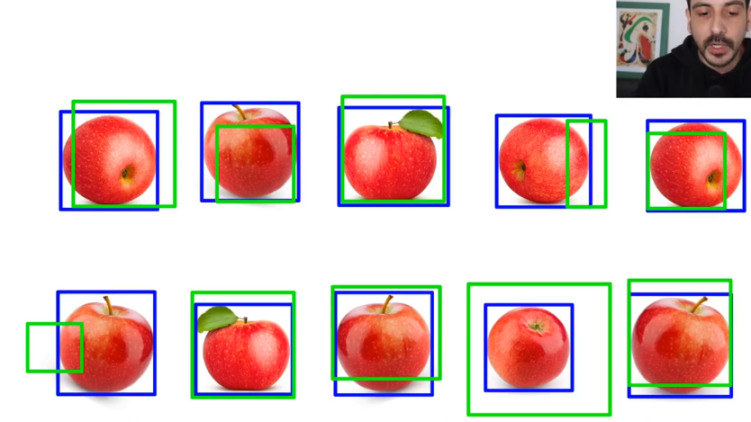

Ground truth with predictions on top.

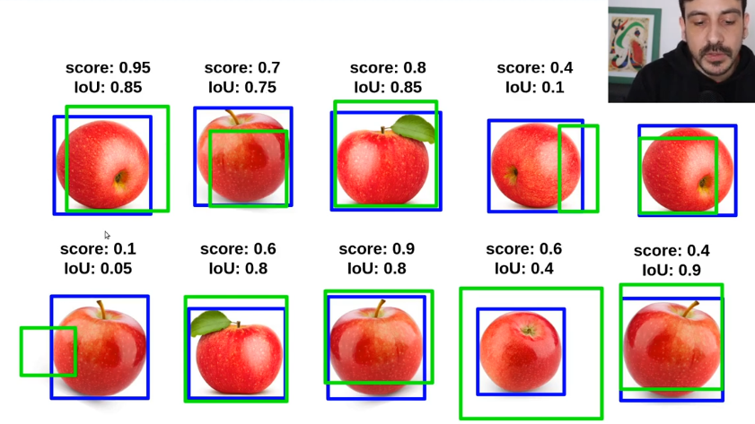

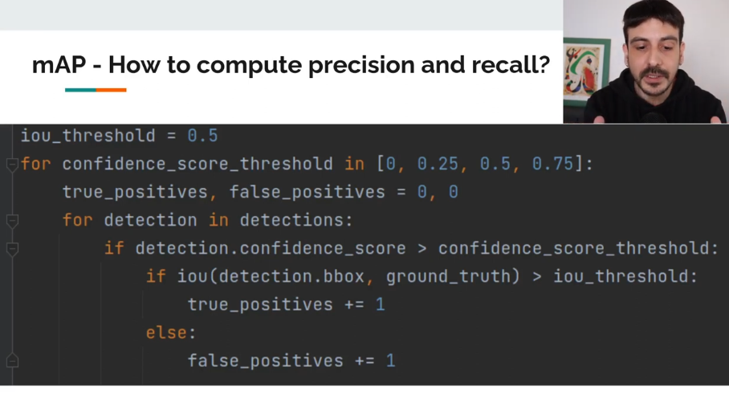

Above is **the pseudocode** for the mean Average Precision.

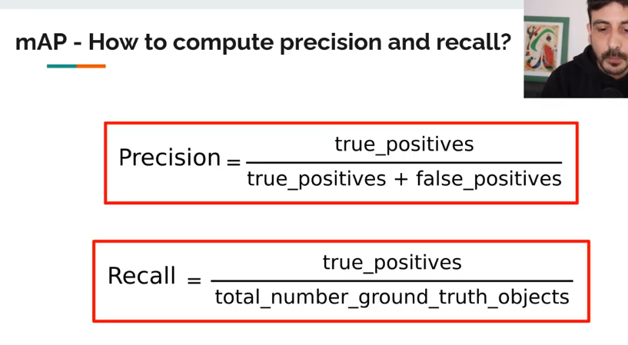

We have 10 ground_truth_objects.

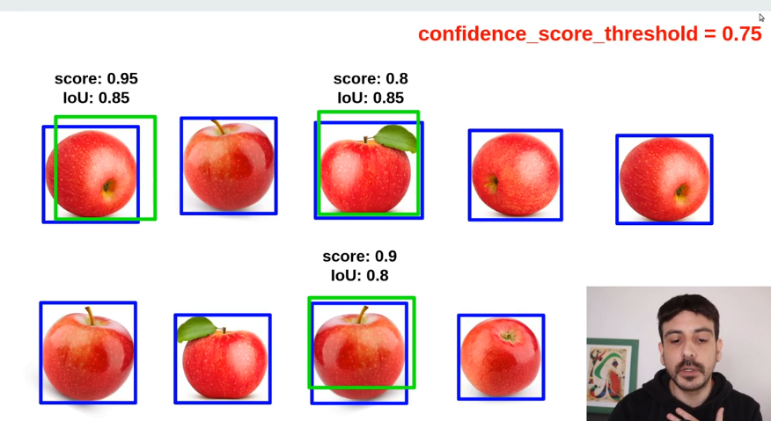

Keep only the objects that have a confidence score of greater than 0.75.

Then if the IoU is greater than our **iou threshold** of **0.5** we increment the true positives and if lower we decrement the false positives.

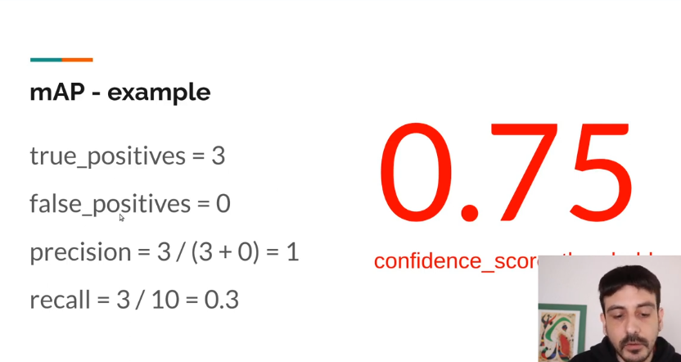

**Now with another example.**

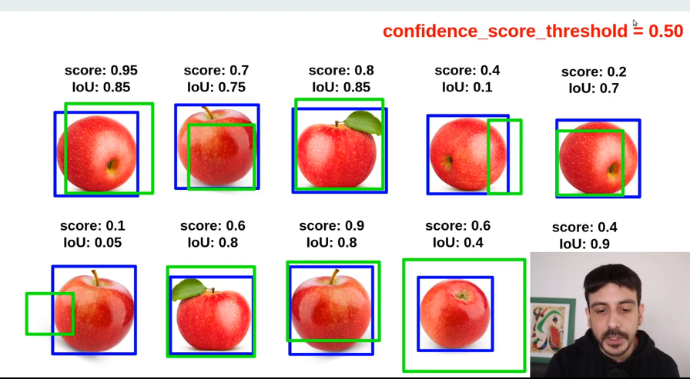

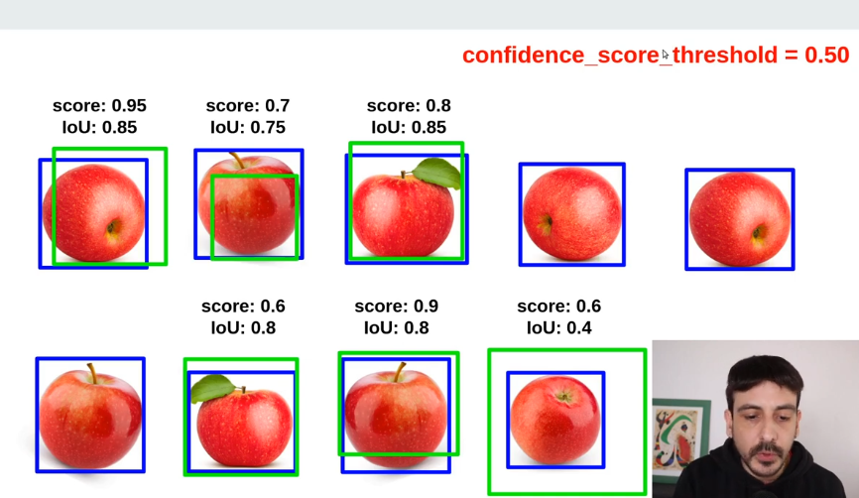

Above are detections with a confidence score less than 0.50.

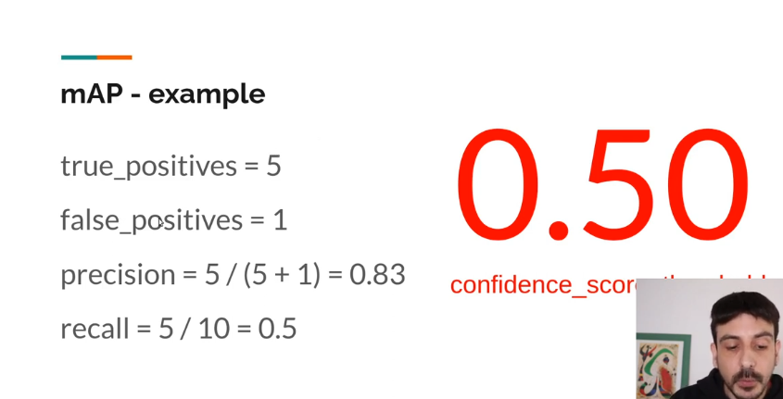

**Another example:**

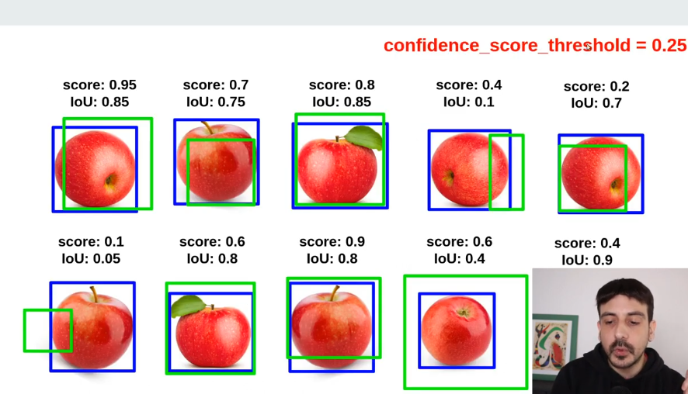

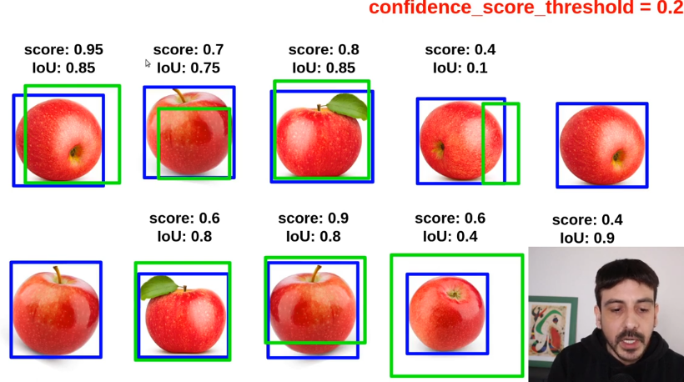

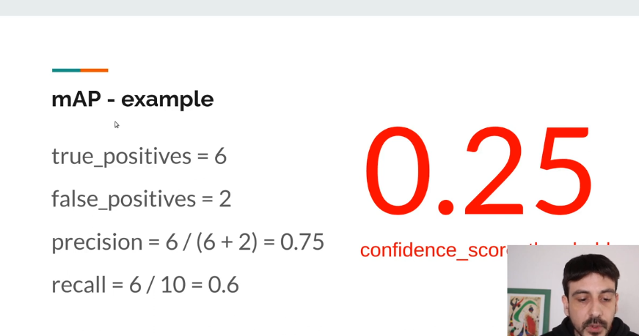

Lastly

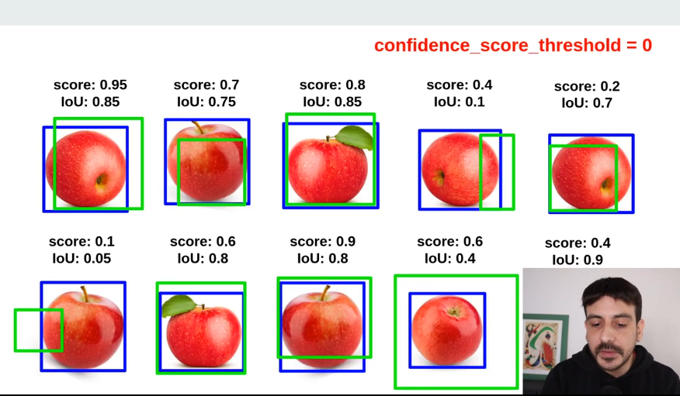

No filtering occurs.

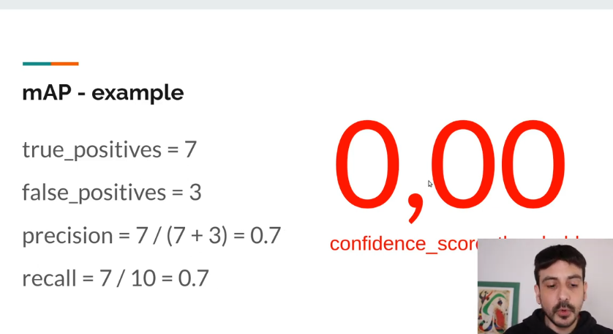

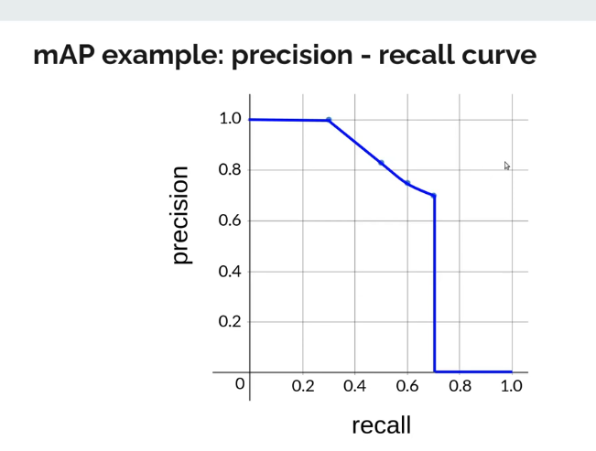

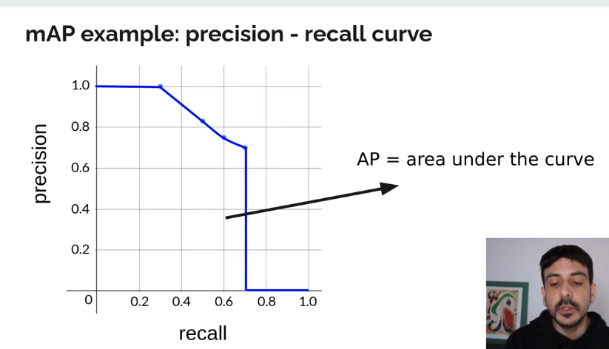

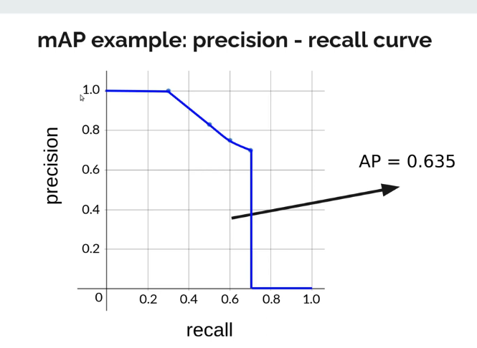

AP – Average Precision

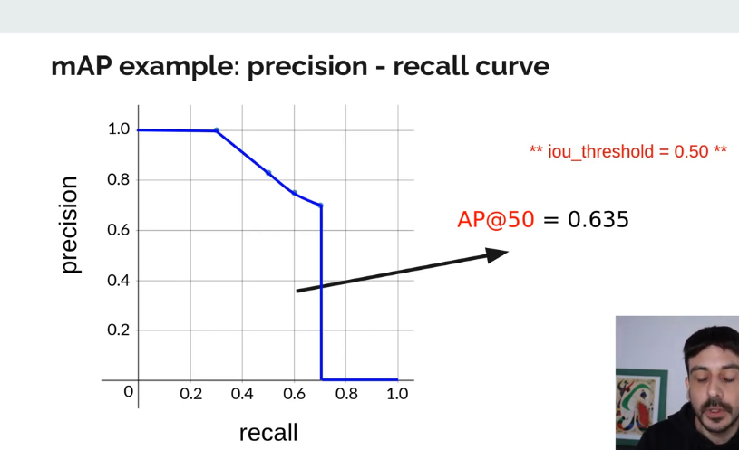

**NOTE:** iou_threshold = 50 is sometimes called the Average Precision at 50.

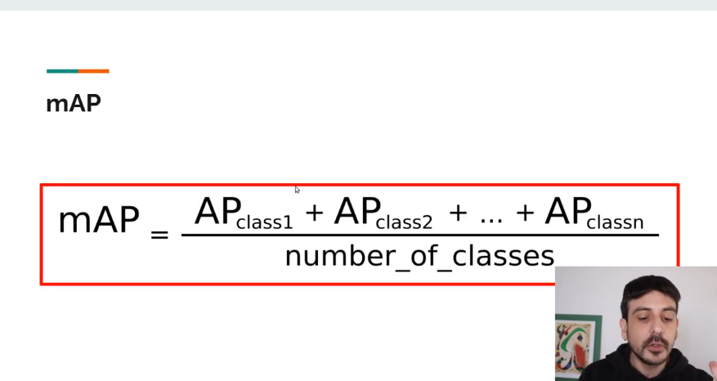

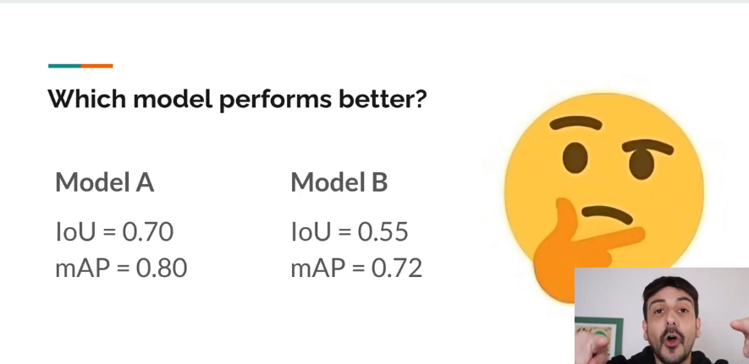

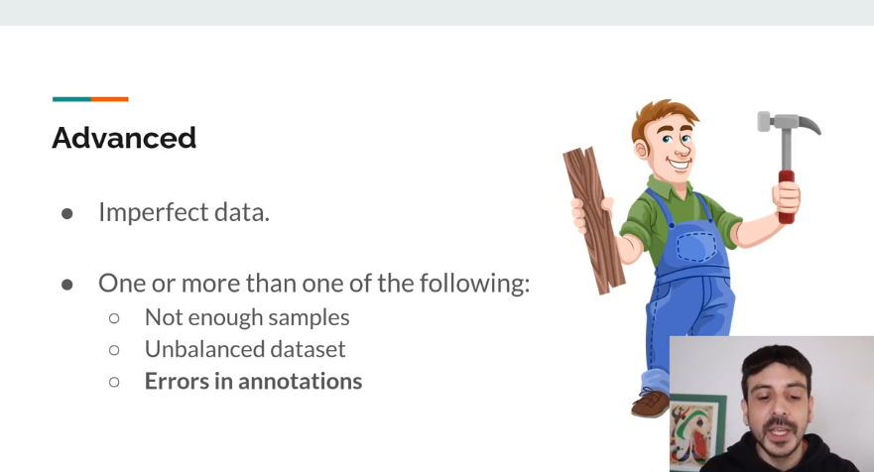

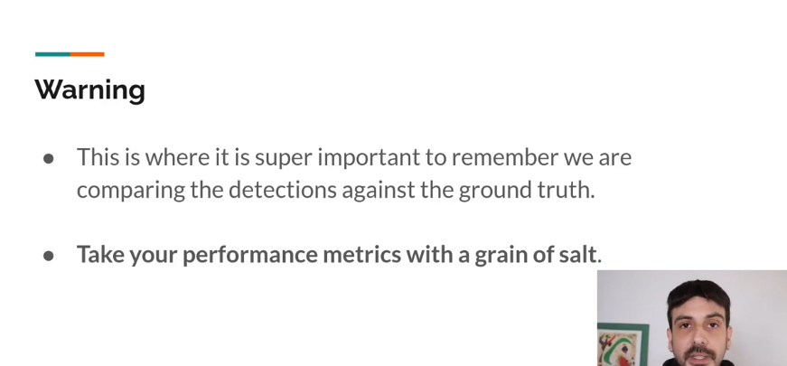

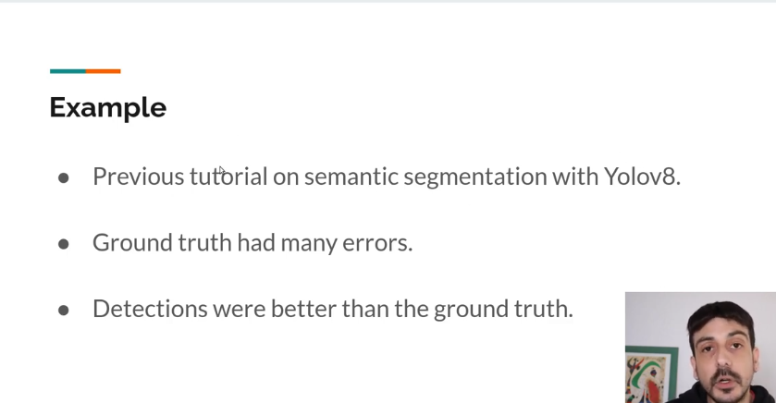

**DATA COLLECTION**

[**https://storage.googleapis.com/openimages/web/index.html**](https://storage.googleapis.com/openimages/web/index.html) **a good source of image datasets.**

**Go to app.cvas.ai – Computer Vision Annotation Tool to do annotations online for free.**

**DATA ANNOTATION**

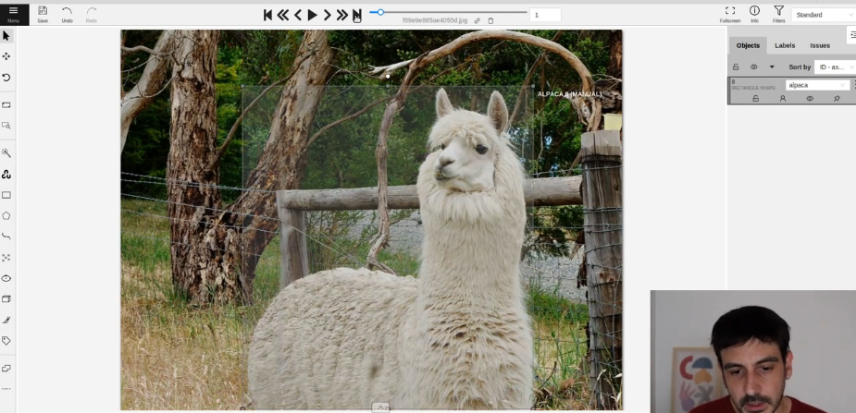

The idea is to annotate only and only the required object.

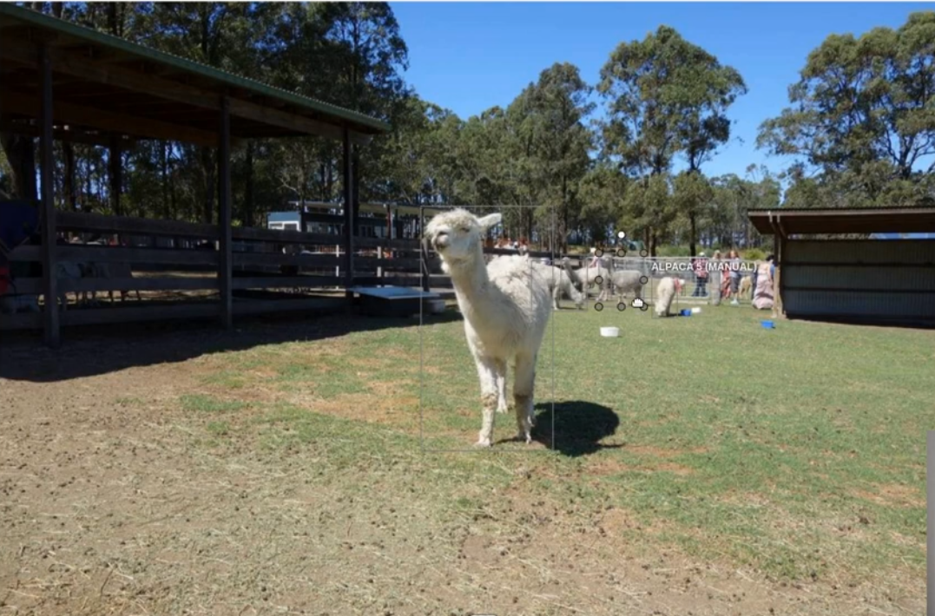

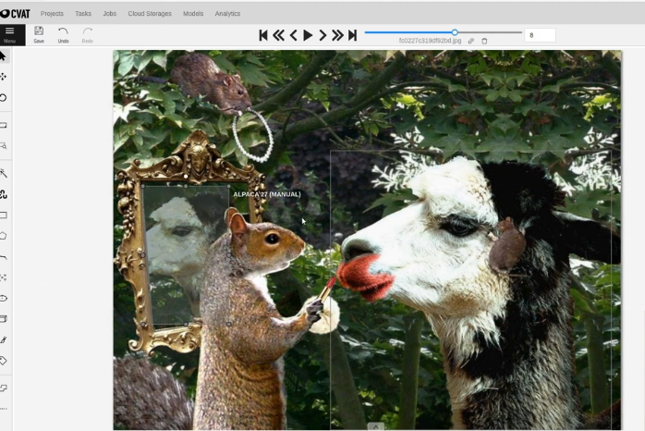

NOTE: for the automatic Open Image Dataset script, run it from VS Code

**How training can be done from command line.**

* **yolo detect train data=config.yaml model=”yolov8n.yaml” epochs=3**

**TRAIN YOLOV8 on Google Colab 1hr 15min**

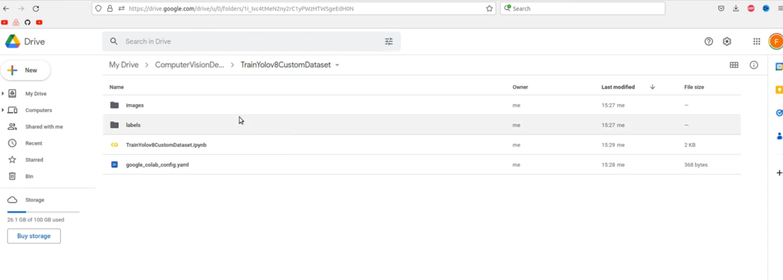

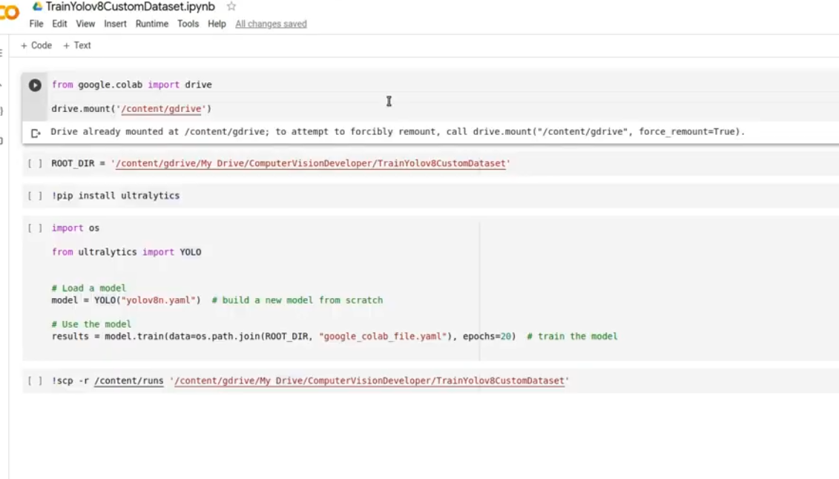

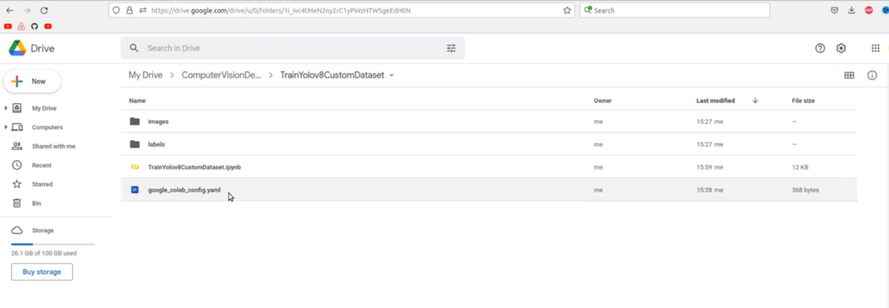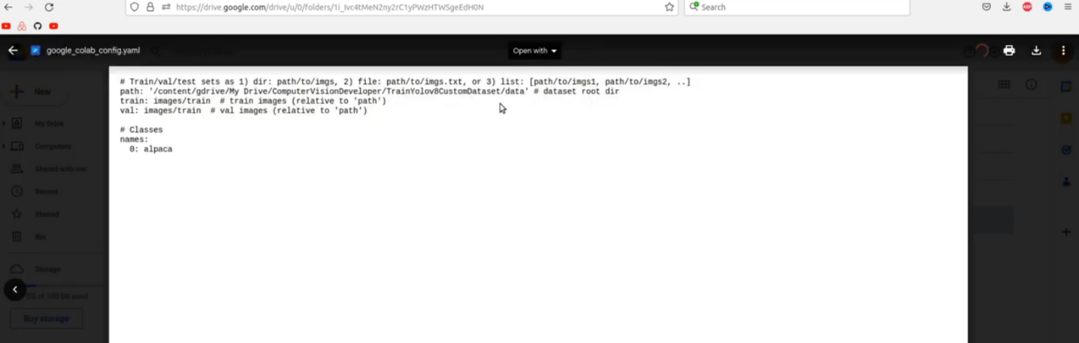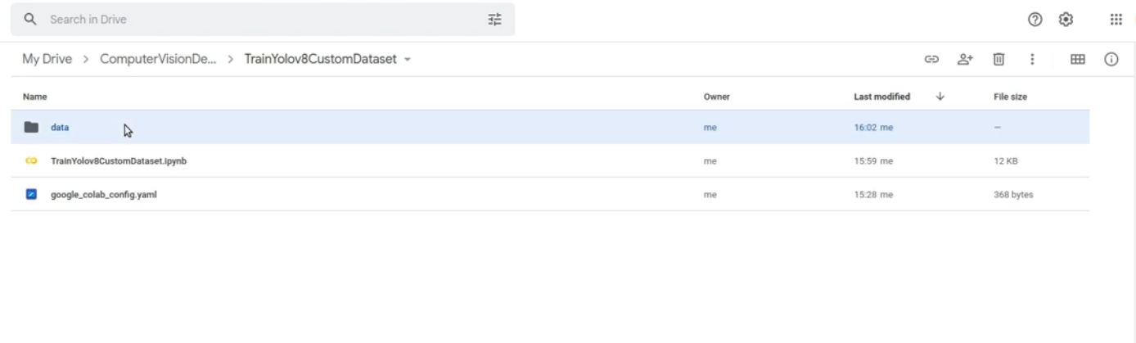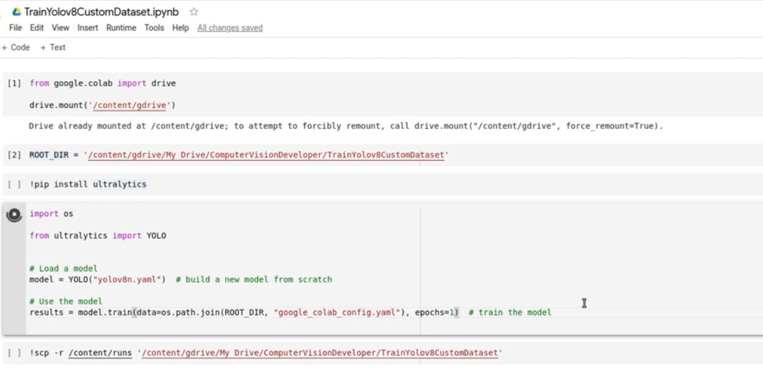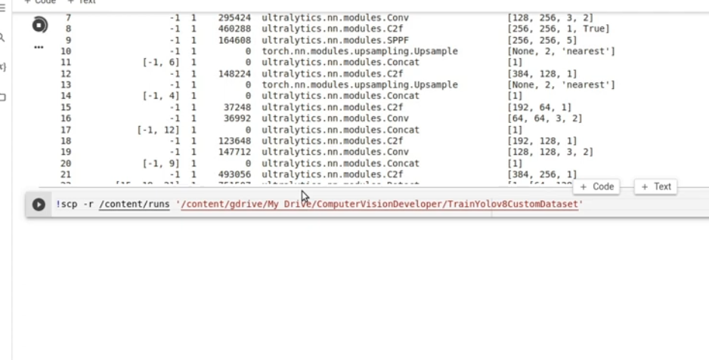

Make sure to execute the last line such that you can move all the results to an actual folder on your Google drive.

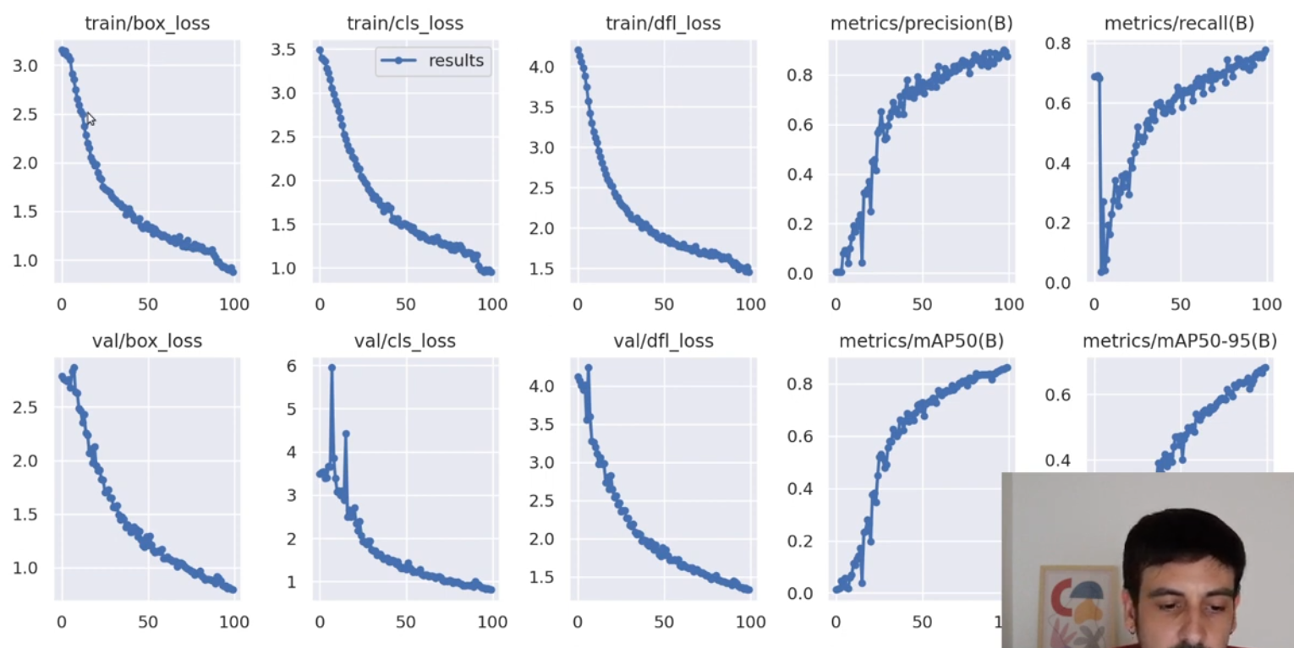

NOTE: **Make sure all your losses are going down.**

Analyzing your model: 1hr 30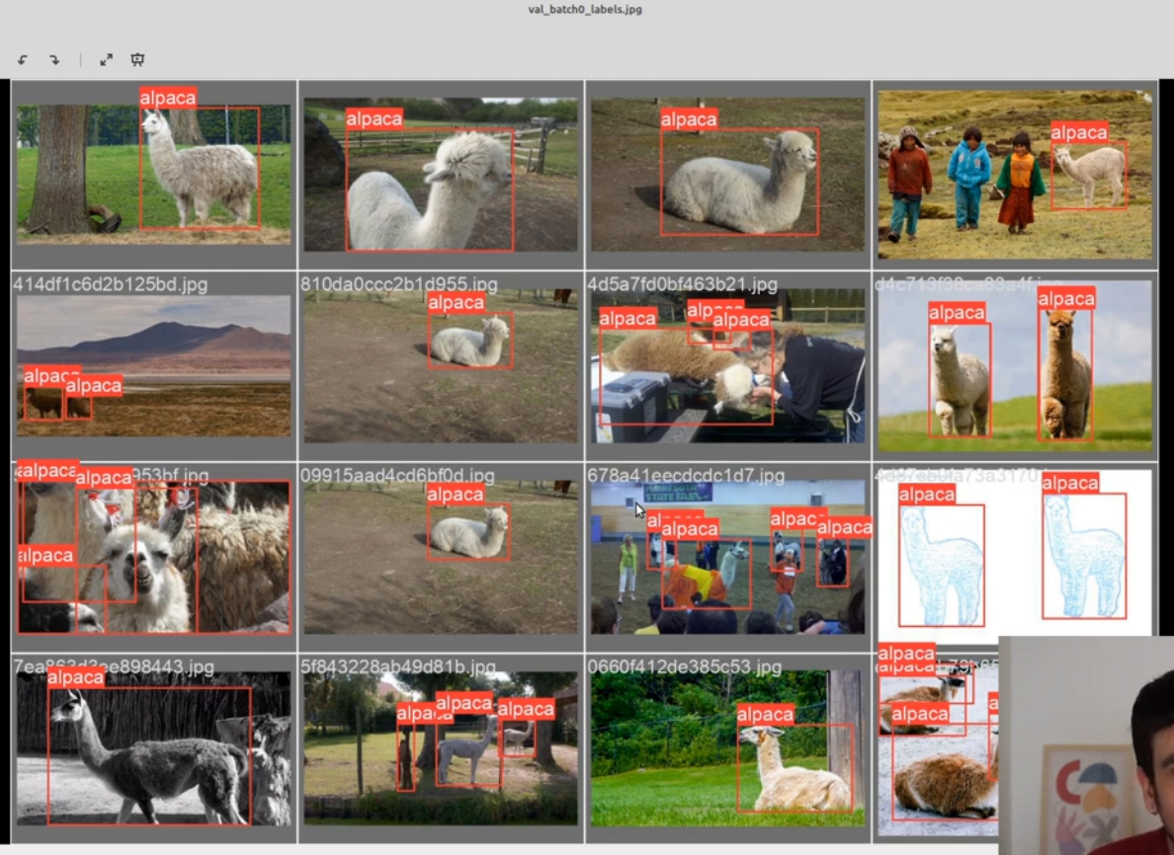

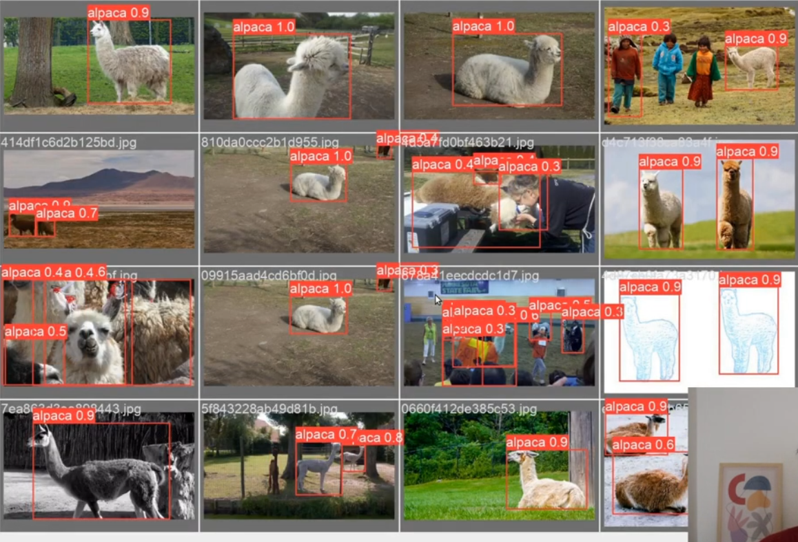

It’s good to use this to analyze your model.

**NOTE:** It takes close to 3hours to train data up to 50 epochs on my PC currently using CPU.

Training started at 3:30 and ended at 11:03pm